KIS Staff Trip to Auroville
Iti Maloney, January 21-23, 2018

Five members of the Kodaikanal community involved in the local recycling initiative visited Auroville on January 21-23: (1) Mr. William, grounds supervisor of KIS and in-charge of waste collection in campus, (2) Clinton, maintenance worker who collects garbage and segregates waste in the school recycling shed, (3) Iti Maloney, SEED Dept. teacher, (4) Danish Kahn, local environmentalist looking to start recycling in Vattakanal, and (5) Raja Mohamad, local scrap dealer in Kodaikanal collecting waste from KIS and most other schools and some hotels.
The purpose of this trip was to learn about various sustainability practices in Auroville which could be implemented in KIS and Kodai. The focus of this trip was on solid waste management, and the group also learned about and visited other organizations that work in areas such as composting, ecologically friendly construction, and general environmental advocacy. The following summarizes the organizations/people visited:

Eco-Service: Palani Kanan and Kali
Eco-Service is a public waste management service that collects trash and recyclables from all the communities of Auroville. Waste is segregated into 8 categories in communities and households. Once the waste is brought to Eco-Service, it is further segregated into 82 categories. The Eco-Service employs women from a nearby village to sort and separate the dry waste into many categories such as flat paper, crumpled paper, news paper, LDPE plastic, HDPE plastic, and so on. The main purpose of visiting the Eco-Service for Mr. William and Clinton was to learn about how to manage such a center while remaining neat and organized. One of the challenges of maintaining the recycling center at KIS is ensuring that all materials are segregated and kept well organized.
The group spent several hours at the Eco-Center with Mr. Palani Kannan and Ms. Kali who run the Eco-Service, learning about the 83 categories of waste, where the materials are sold, how the accounts are kept track of, and the process of waste collection from different neighborhoods. Mr. Raja Mohamad was most interested in learning about the recycling factories and other buyers in Pondicherry.
Our group also spent a morning with Palani Kanan visiting several communities in Auroville to see how each of them individually segregate their waste in the 8 categories required by the Eco-Service. Each neighborhood/community designs their waste center according to their own challenges, whether it be an issue with dogs, other animals, rain, etc. We saw some interesting and creative designs for trash can lids which are easy to take on and off.

AuroCreation: Parsad
Mr. Palani Kanan took us to a center where all thrown away styrofoam/thermocol in Auroville is sent. The thermocol is ground into very small pieces, and is mixed with sand and cement during the construction process. AuroCreation has successfully made buildings using only this material. We learned that the main drawback of this method of construction is that when exposed to too much heat, toxins can be released from the thermocol into the air of the building. They recommend that this kind of construction mainly be used for store-rooms, outdoor toilets, and other buildings not used as homes.
WasteLess: Ribh Vora

WasteLess is an organization that creates waste management and recycling education materials for children ages 7-15. During our visit with WasteLess we learned about a new lesson plan guide known as Garbology Lite, available to teachers for free online. The only condition to using their free material is that every teacher must complete a feedback form for WasteLess on each lesson conducted. The Garbology Lite booklet is an improved and shortened version of the Garbology 101 Kit that KIS has already purchased from WasteLess. This visit was most productive for Iti Maloney as she is the KIS SEED teacher for students from 6-8th grade.

Earth&Us: Minhaj Ameen and Vijay Mathew
Earth&Us is an organization that seeks to develop creative sustainability practices. It creates education and advocacy materials on waste management and broader environment issues for an adult population. The main purpose of visiting this organization was to learn about how they have educated communities and other adult groups on environment topics such as solid waste management and conscious consumerism. Earth&Us is known for running a “Happiness Workshop” in which they combine the topics of consumerism and happiness, and guide the participants in understanding that it is largely not material things that brings one happiness. Earth&Us also collaorates with a local theater group in Pondicherry which puts on a comedic drama about waste management, and has been very successful in educating the audience about these serious issues. Minhaj and Vijay are happy to share some of their education resources with our group to test in Kodaikanal.

Trash Mahal: William Sullivan
William Sullivan is a resident of Auroville who wanted to prove that many waste or trash items could be used in the construction of a home. We visited his home and learned how he incorporated items like glass bottles, tetra-packs, broken pottery, fallen down tree branches, petrol bunk hoses, and other random items in the construction of his home. We were particularly interested in the recycled tetra-pack material. Currently in Kodaikanal, there is no market to sell used tetra-pack which is used to package juice, milk, and other liquids. We learned that there is a factory in Gujarat which buys tetra-pack, and recycles it into flexible plywood-like sheets and roofing material. Raja Mohamad is interested in contacting this factory.
It was also interesting to learn how the community Mr. Sullivan lives in manages toilet waste. All houses have “dry toilets:”waste is mixed with sawdust and converted into compost within 6 months.

Earth Institute:
The Earth Institute, recognized by UNESCO, is an organization that specializes in research, development, and promotion of building techniques using pressed earth. We visited their exhibition hall to learn about the various methods of creating compressed earth brick, with addition of small amounts of cement. The Earth Institute conducts regular trainings and workshops on sustainable building practices, some of which are open to individuals with no construction or architecture background.

Solar Kitchen Composting:
As the Solar Kitchen serves food for hundreds of people a day, we were interested to learn how they manage their food and other waste. We saw that all waste from packaged goods is segregated and organized for the Eco-Service to collect weekly. Food waste from peelings are kept aside and added to their compost pit in the backyard. The compost pile is covered with soil, grass, and leaves to cover the smell and prevent animals from creating a disturbance. We also saw that there is hardly any food waste coming from trays in the Solar Kitchen as they have successfully built a reputation of zero tray waste.

Sacred Groves: Manu Gopalan and Aman Ali
Sacred Groves is an ecological housing project in Auroville that strives to replace the current “toxic building process” with sustainable and ecologically friendly solutions. The members believe in constructing buildings primarily with the resources at the building site -- using wood, soil, water, and other resources from that plot area itself. They use minimal cement in their buildings, and largely build with compressed earth. They conduct workshops throughout the year to individual with no construction or building background.
One center which we all wanted to visit but could not because of time constraints is the Upcycling Center, a place in Auroville which converts recyclable items into other interesting objects. For example, they have turned tetra-packs into wallets for children, and old cassette tape material into hats. If anyone from KIS plans to visit Auroville soon, it would be worth visiting this center and sharing with the KIS community how different materials can be upcycled.
See photos below.
---------------
William Gynanaraj Trip Report

Though I made a short visit to Auroville before, this time we spent enough time there and at Eco-service to understand their solid waste management practices and associated industries.
We took Mr. Clinton with us, a contract employee working at the KIS recycling shed. He manages the KIS facility for sorting of recyclables, but he never realized that the recycling shed should be kept clean, and that he has to organize the incoming dry-waste systematically. This Auroville visit changed his perception; he learnt the importance of keeping the shed clean.
The Eco-Service model of waste management in Auroville is good, but for Kodaikanal and KIS, it won’t work. For KIS, manpower is the main obstacle; we don’t have enough staff to handle generated solid waste. If we can hire more employees at our recycling shed and one fulltime driver (Clinton has licence with badge; he could be permitted to also drive) we can recover more recyclables from trash.
KIS should form a specific team for handling campus solid waste. Roles and responsibilities should be defined for each staff. Schedules should be made for waste pickups and selling recyclables.
Auroville has achieved 60-70% recycling by adopting incentive systems. People are encourage to perfectly do source segregation by adopting a user fee system. People who practice good source segregation and send clean materials for recycling shed are paying less money for collecting (userfee) their waste. If KIS can implement “fine system” for the operational and household amma’s for not doing segregation may make bigger impact.
Sometimes valuable antique materials are missing at recycling shed. Presently, there is no fencing in the shed, so fencing is one of our immediate priories.
Pictures

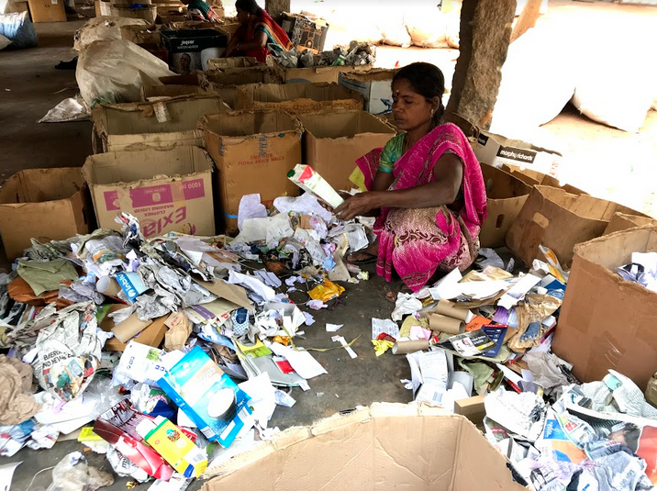 | Image 1  Amma at recycling center sorting waste
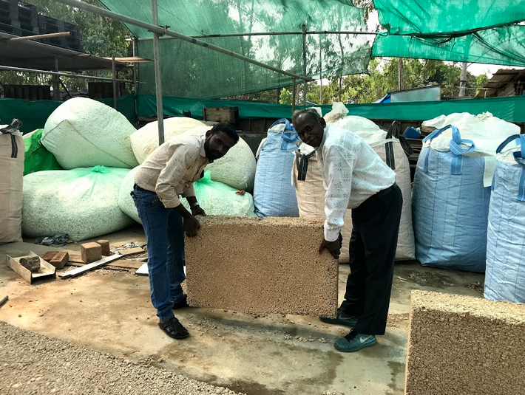 | Image 2  Thermocol construction center
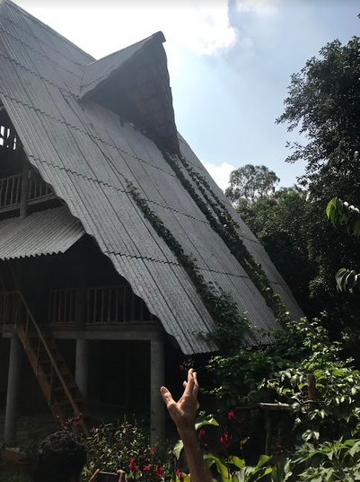 | Image 3  Tetra-pack roofing panels
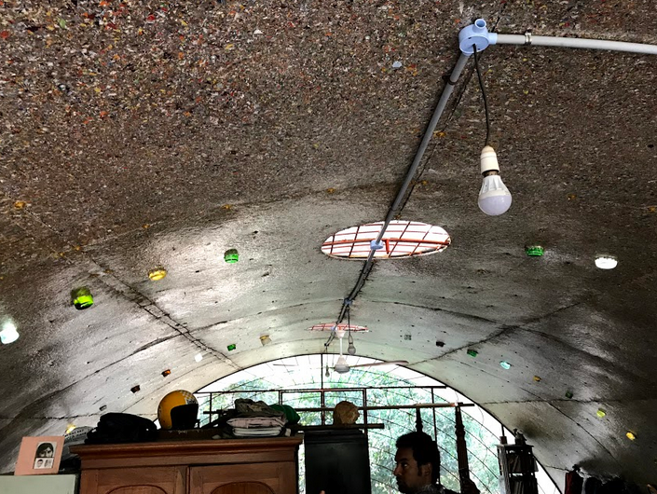 | Image 4  Tetra-pack flexible panels for ceiling
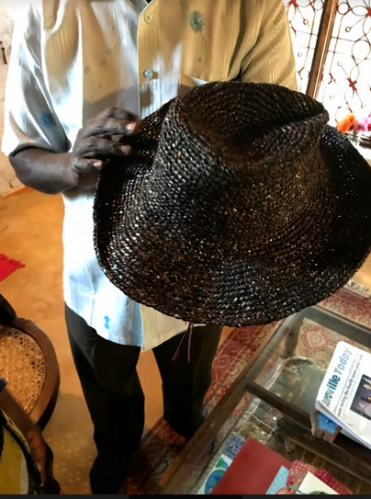 | Image 5  Hat made of cassette tape
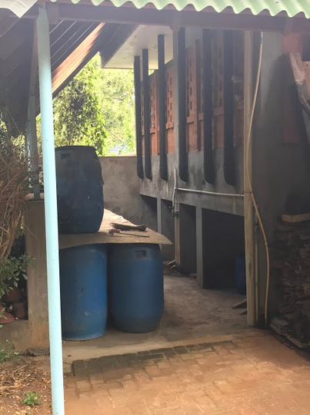 | Image 6  Dry toilet composting
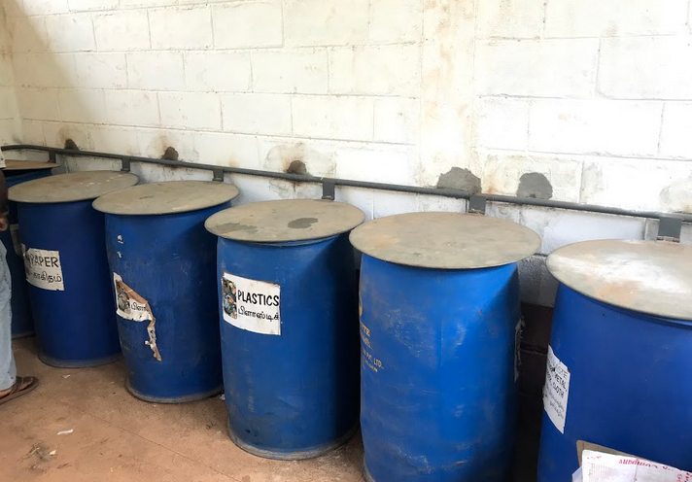 | Image 7  Trash barre s with lids

