John Clifford Easter (March 21 1935 – June 17 2018)
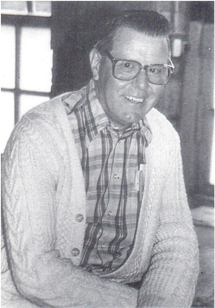
If you ever heard a loud Canadian shout in the corridors of the Quad ‘Great Caesar’s Ghost!’, or ‘Like Potatoes in a potato sack!’… You knew it was John Easter!
Mr Easter brought the English Department to life with his funny phrases, his laugh, and love for teddy bears!
John and Martha Easter came to Kodai in 1978, and remained for 19 years. They actively participated in social community work. All their children, Martha Jean (’83), Ian (’86) and Elizabeth (’91) graduated from KIS.
John Easter was quite the storyteller, and the song maker. He could come up with songs for just about anything and anyone. He even made learning English grammar seem like ‘spreading peanut butter on bread’!
Little kids used to look forward to children time at church with him, for he had a way to bring Christian stories and messages to life. A conversation or meeting with him inevitably meant you were going to come out laughing.
John and Martha Easter retired in 1997 from Kodai. In 2011, they moved to their final place of residence in Edmonton, Canada.
Mr Easter led a successful 40-year career as a high school English teacher. He inspired many of us inside and outside of the classroom. His joy was contagious.
May you rest in Peace John Easter.
– Manjusha Ninan, Alumni Coordinator

